Document Title | Document Code | Document Type | Issue No | Sop No.
Shared Service  Software Service Catalog | S-SW-SC | SOP | 01 | 5 SS
Issue Date | Effective Date | Copy No. | Revision No.
01/10/2025 | 01/10/2025 | Master | 0

Purpose
Standardize the intake, evaluation, and fulfillment of software service requests from AKG subsidiaries through a centralized catalog. Ensure transparent prioritization, SLA-bound delivery, and continuous alignment of development efforts with subsidiary business needs.
Procedure & Flow
Step 1: Service Request Submission
- Action:
  - Subsidiary submits request via AKG software Request Form.
  - Fill Meeting in Minutes Form by Business Analyst.
  - Requirements List Form by Business Analyst, Software Supervisor and Software Manager.
    - Required fields: Priority (P1 > P4), impacted subsidiaries.
  - Requests Log Form by Software Manager & Software Supervisor.
  - High-Level Design (SRS, BRD, TFS) by Business Analyst.
- Roles:
  - Subsidiary Liaison: request Form.
  - Business Analyst Fill Meeting in Minutes Form.
  - Software Supervisor Assigns tracking ID.

Step 2: Feasibility Assessment
- Action:
  - Technical Team (Software Supervisor, Business Analyst, Developers, Tester, UI/UX Designer) assesses:
    - Technical complexity
    - Integration points
    - Resource requirements
- Output: High-Level Design document (Backlog TFS).
- Roles:
  - Software Manager: Approves High-Level Design.
  - Software Supervisor & Business Analyst: Leads assessment.
- Timeline: ≤10 business days.
  - Software Manager: Strategic alignment sign-off.
Step 3: SLA Negotiation & Agreement
- Action:
  - Define scope, timeline, cost.
  - Subsidiary signs Service Level Agreement (SLA).
- Roles:
  - Software Manager: SLA owner.
  - Subsidiary Liaison: Agreement ratification.
- SLA Tiers: (maintenance). deadlines.
  - Standard: Pre-approved modules (e.g., customization) > 5-week delivery.
  - Complex: New features (e.g., API integration) – Phased delivery per agreement.

Step 4: Development & UAT
- Action:
  - Execute per SOP SW-G1 (Software Development Lifecycle).
  - Subsidiary validates in User Acceptance Testing (UAT) environment.
- Roles:
  - Business Analyst Document.
  - Technical Team: Builds solution.
  - Subsidiary Users: UAT execution Software Supervisor, Business Analyst, Software Test.
Step 5: Deployment & Feedback
- Action:
  - Release to production; monitor for 72h (according to the case).
  - Subsidiary satisfaction survey.
- Roles:
  - Software Supervisor: Deployment oversight.
  - Shared Service Coordinator (Business Analyst, Software Supervisor, Software Manager): Feedback consolidation.
Documents & Records
- Service Request Forms by Shared Service Coordinator
- Feasibility Assessment Reports by Software Manager
- Post-Implementation Surveys by Shared Service Coordinator
- Request Form by End User or Stakeholder.
- Request Meeting in Minutes Form by Business Analyst.
- Requirements List Form by Business Analyst, Software Supervisor and Software Manager.
- Requests Log Form by Software Manager & Software Supervisor.
- High-Level Design (SRS, BRD, TFS) by Business Analyst.
- Prioritization Matrix by Technical Team.
- Release Form & Log form by Supervisor.

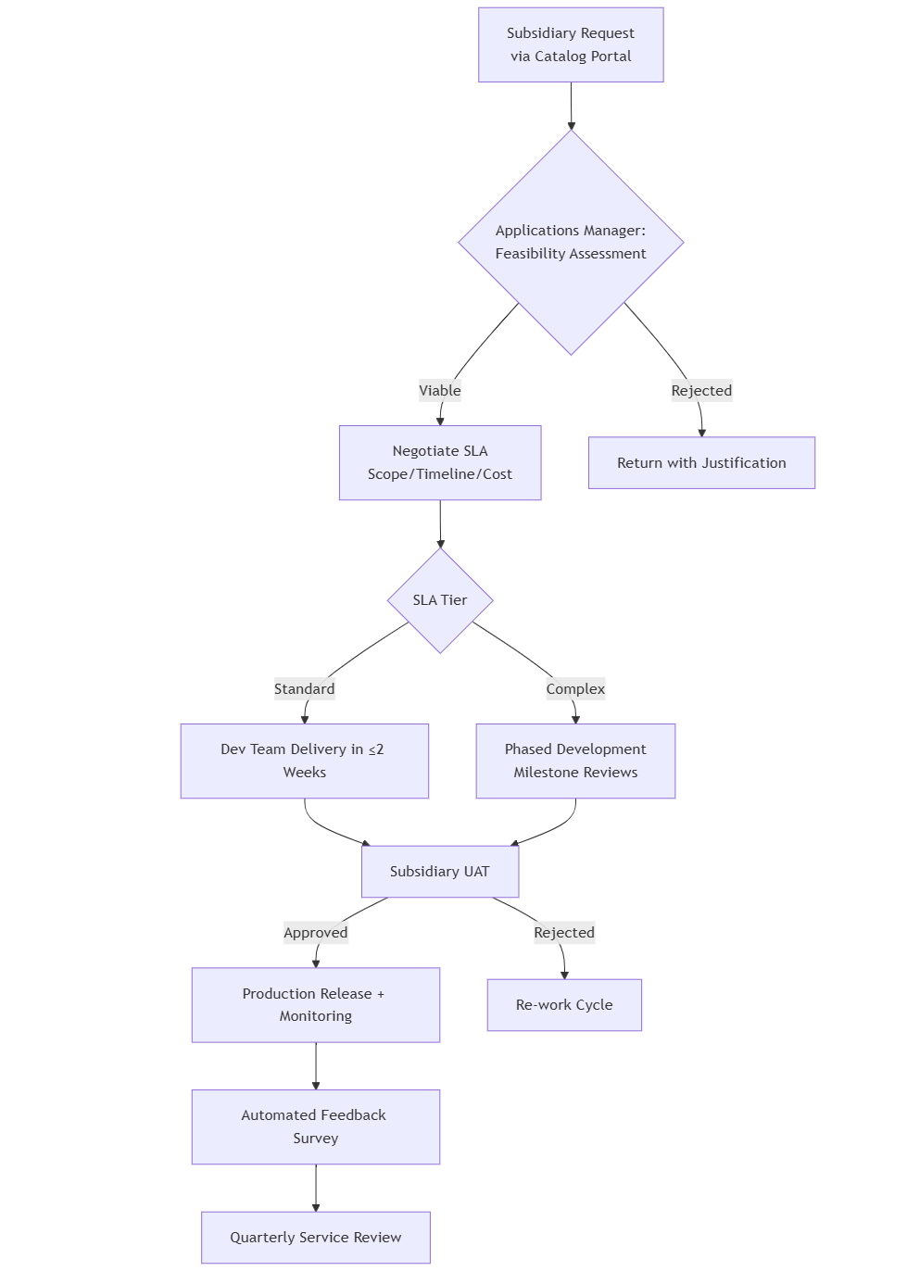

Forms
Form Name | Form Code
Request Form | F-SW-SD/01
Request Meeting in Minutes Form | F-SW-SD/02
Requirements List Form | F-SW-SD/03
Requests Log Form | F-SW-SD/04
Release Form | F-SW-SD/05
Release Log Form | F-SW-SD/06
Bug Form | F-SW-SD/07
Bugs Log Form | F-SW-SD/08
Feedback Survey Form | F-SW-SD/09
Feedback Survey Log Form | F-SW-SD/10
Product Backlog TFS
Sprint Backlog TFS
Task TFS
Bug TFS
Release Test TFS as Task
Release Live TFS as Task

Revision History
Rev No | Rev Date | Issue No | Issue Date | Description of Change | Approved By
0 | 01-10-2025 | 01 | 01-10-2025 | Initial Issue

